**Conceptual Design**

**1.Sitemap**

**2.GUI(s)**

Login Page

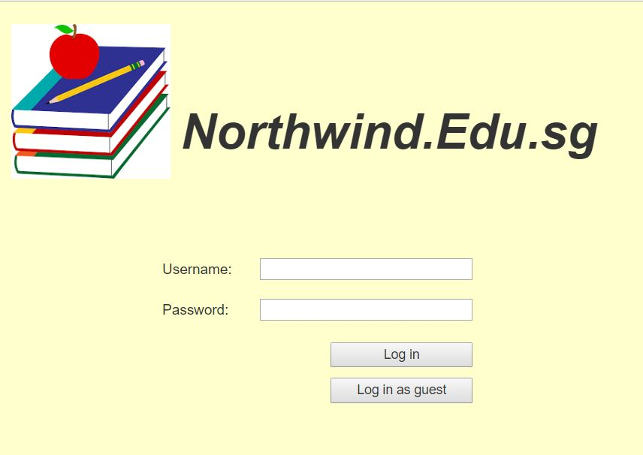

HomePage>About Us

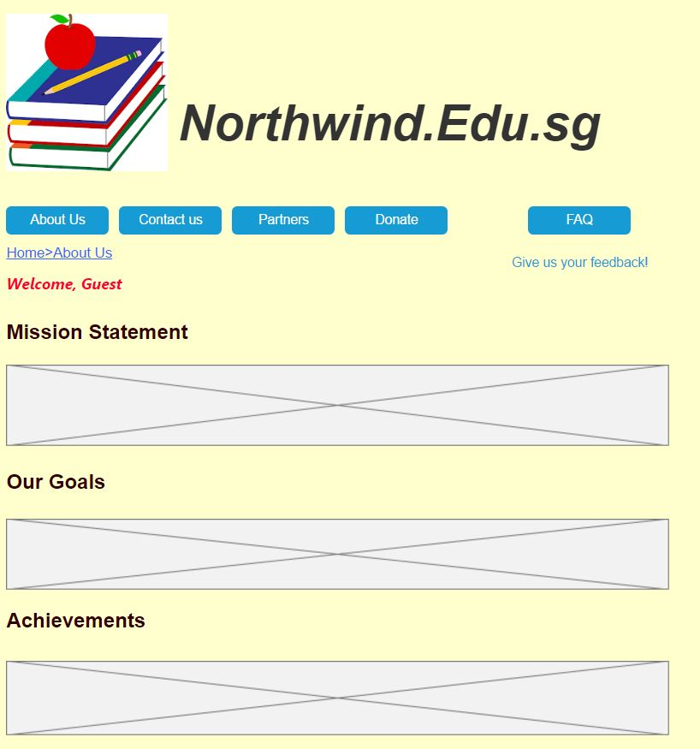

HomePage>Contact Us

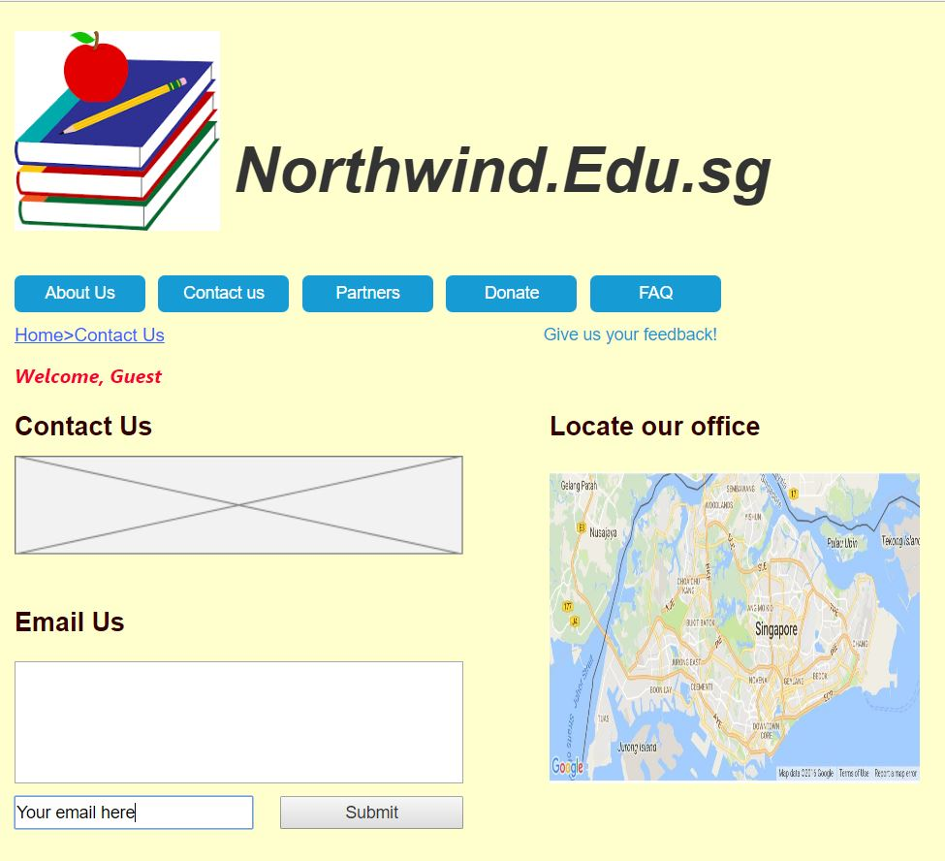

HomePage>Partners



HomePage>Donate



HomePage>FAQ

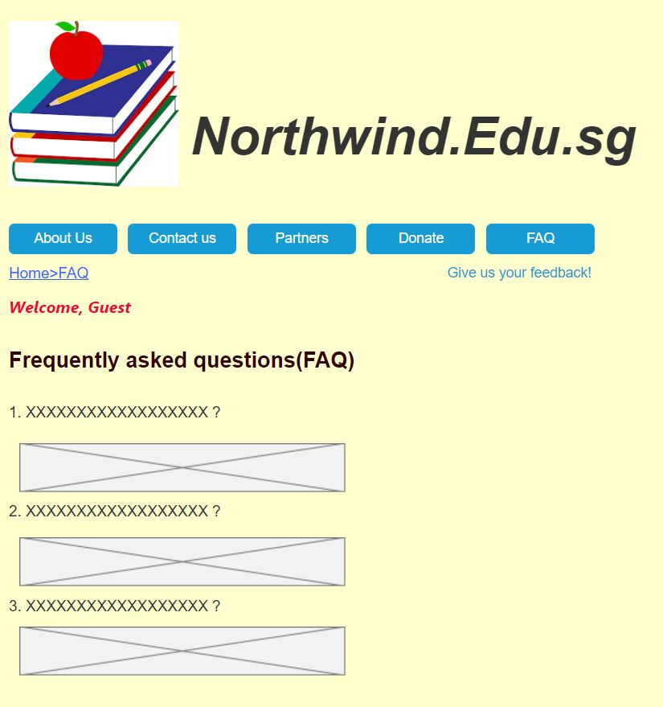

HomePage>Feedback

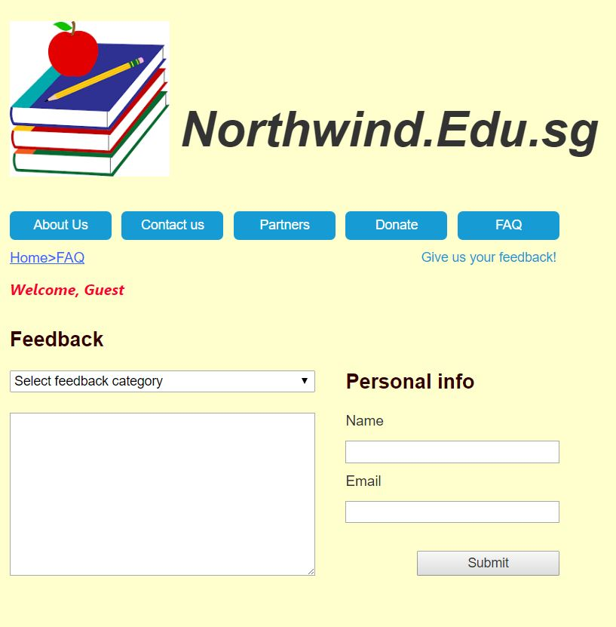

Homepage for guest

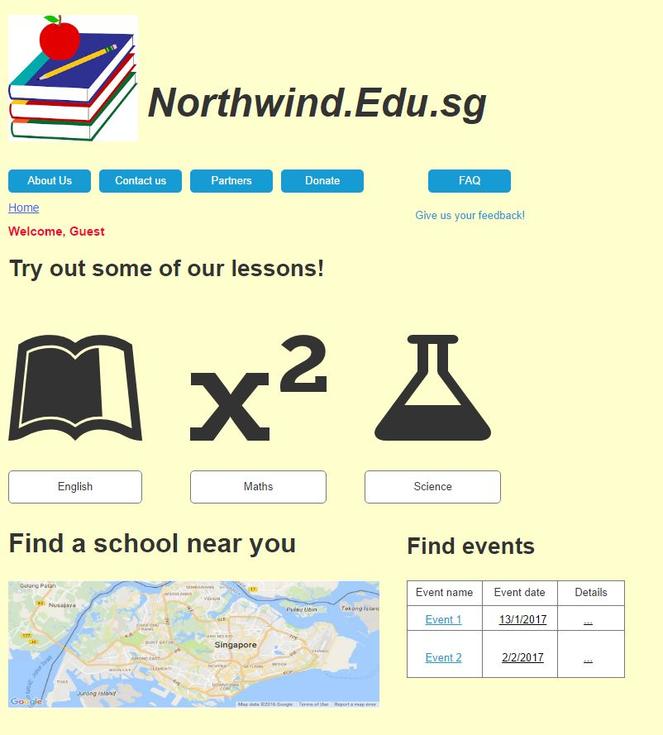

Homepage for Admin

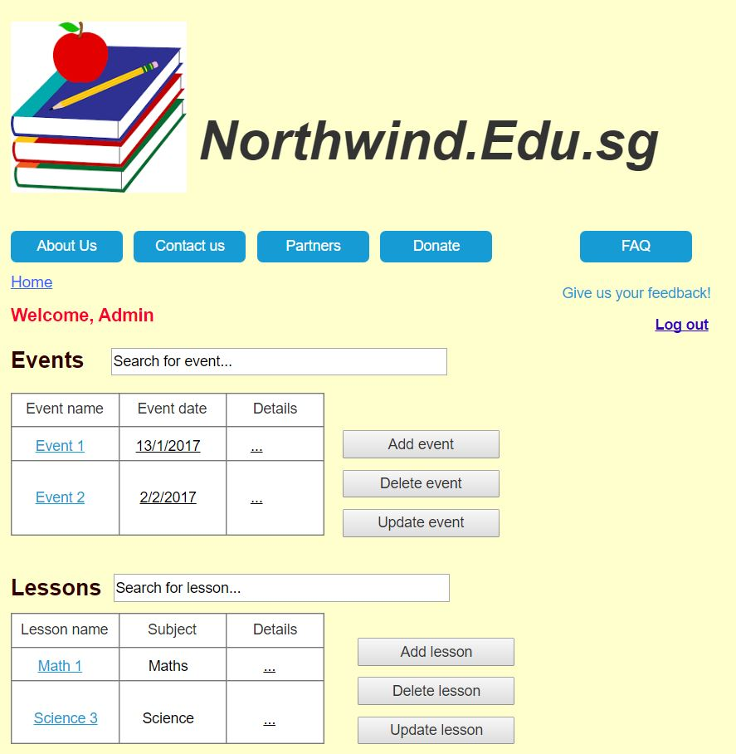

Homepage for Member

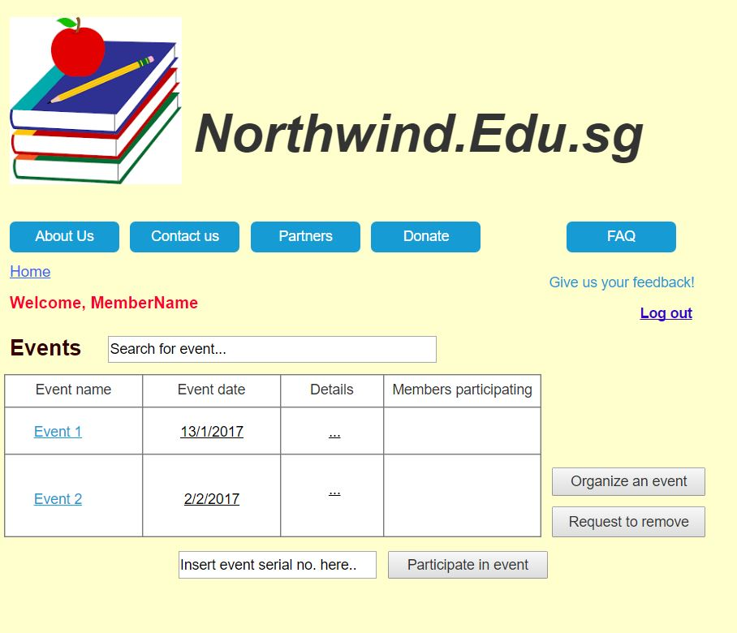

**3.Data Tables**

Users

|  |  |  |
| --- | --- | --- |
| Column | Data Type | Null? |
| Username (PK) | Varchar(25) | No |
| Password | Varchar(25) | No |
| Access Level | Int | No |

Events

|  |  |  |
| --- | --- | --- |
| Column | Data Type | Null? |
| Event ID (PK) | Varchar(6) | No |
| Event Name | Varchar(30) | No |
| Event Date | Date | No |
| No. of Participants | Int | No |
| Location | Varchar(50) | No |
| Details | Varchar(100) | Yes |
| Organizer ID(FK) | Varchar(10) | No |

Organizers

|  |  |  |
| --- | --- | --- |
| Column | Data Type | Null? |
| Organizer ID(PK) | Varchar(20) | No |
| Organizer | Varchar(25) | No |
| Company | Varchar(30) | No |

Schools

|  |  |  |
| --- | --- | --- |
| Column | Data Type | Null? |
| School ID(PK) | Varchar(20) | No |
| School Name | Varchar(25) | No |
| School Location | Varchar(60) | No |
| Website | Varchar(60) | No |

Courses

|  |  |  |
| --- | --- | --- |
| Column | Data Type | Null? |
| Course ID (PK) | Varchar(25) | No |
| Course Name | Varchar(25) | No |
| Course Detail | Varchar(100) | No |
| Location | Varchar(30) | No |

**3.Task Distribution**

Conceptual Design  
-Sitemap (Hong Wei)  
-GUI (Hong Wei)  
-Tables (Abdul Hakiim)

1. **Objectives**

The objectives of this project is to achieve universal primary education through the use of technology to solve Asia’s toughest problems particularly by implementing an ASP.NET web application.

1. **Functionalities**

|  |  |
| --- | --- |
| **Functionalities** | **Done by** |
| Design   * Layout(Website) * Images * Colour Scheme |  |
| Hong Wei |
| Hong Wei |
| Both |
| Database   * Tables * Data |  |
| Abd. Hakiim |
| Abd. Hakiim |
| Website   * Master Pages * Login (Logging in, Create Account, Session variables etc.) * Guest’s Pages   + Descriptor pages (About us, FAQ, Contact Us, etc.)   + Content Pages (Lessons, Events, Feedback, Donations) * Member’s Pages   + Descriptor pages   + Organizing of events   + Change of account details   + Adding of contact number and company to personal info * Admin Pages   + (Donation page) View all donations   + Insert/Delete/Update Schools/Courses   + Able to view feedbacks   + Able to Insert/delete/update Events |  |
| Hong Wei |
| Abd. Hakiim |
|  |
| Abd. Hakiim |
| Both |
|  |
| Both |
| Abd. Hakiim |
| Hong Wei |
| Both |
|  |
| Hong Wei |
| Hong Wei |
| Abd. Hakiim |
| Both |

**Sitemap**



1. **Limitations**

We had several limitations when implementing our website. A few of them are using CSS to better design our website, using select, update and delete through GridView Autogenerate options, implementing HTML 5, thinking of more member privileges and mostly time.

1. **Conclusions**

We learnt about the different types of features we could add to our website, such as google maps, YouTube videos, etc. We also learnt to make use of DataAdapters, DataReaders to bind our data to our Grid view and such, rather than just using DataSource. This gives us the opportunity to add in more features to our site rather than just displaying it. Overall, we learnt that there are many ways we could have done our website, such as using HTML5, CSS and more.

1. **Codes**

**Login**

public partial class Login : System.Web.UI.Page

{

int a = 2;

string name;

protected void Page_Load(object sender, EventArgs e)

{

a = 2;

}

protected void btnLogin_Click(object sender, EventArgs e)

{

SqlConnection con = new SqlConnection("Data Source=WEI;Initial Catalog=EducationNorth;Integrated Security=true"); // making connection

// SqlConnection con = new SqlConnection("Data Source=localhost;Initial Catalog=EducationNorth;user=user; password=Password_2013"); // making connection

SqlCommand cmd = new SqlCommand("Select accessLevel, name from Users where username='" + txtUsername.Text + "' and password ='" + txtPassword.Text + "'", con);

SqlDataAdapter sda = new SqlDataAdapter(cmd);

DataTable dt = new DataTable();

sda.Fill(dt);

con.Open();

int i = cmd.ExecuteNonQuery();

if (dt.Rows.Count > 0)

{

a = Convert.ToInt16(dt.Rows[0]["accessLevel"]);

name = dt.Rows[0]["name"].ToString();

Session["Lvl"] = a;

Session["name"] = name;

Session["username"] = txtUsername.Text.Trim();

if (a == 1)

{

Response.Redirect("HomeAdmin.aspx");

}

else if (a == 0)

{

Response.Redirect("HomeMember.aspx");

}

}

con.Close();

}

protected void btnGuest_Click(object sender, EventArgs e)

{

Session["Lvl"] = 2;

Response.Redirect("HomeGuest.aspx");

}

protected void btnCrAccount_Click(object sender, EventArgs e)

{

Response.Redirect("CreateAccount.aspx");

}

}

**Create Account**

public partial class CreateAccount : System.Web.UI.Page

{

int x = 0;

int y = 0;

protected void Page_Load(object sender, EventArgs e)

{

Label6.Visible = false;

Label7.Visible = false;

Label8.Visible = false;

Label9.Visible = false;

Label10.Visible = false;

}

protected void btnCreate_Click(object sender, EventArgs e)

{

if (txtName.Text != "")

{

x++;

}

else { Label7.Visible = true; Label7.Text = "Please enter a Name"; }

if (txtEmail.Text != "")

{

x++;

}

else { Label8.Visible = true; Label8.Text = "Please enter an Email"; }

if (txtUsername.Text != "" && txtUsername.Text.Length > 3)

{

x++;

}

else { Label9.Visible = true; Label9.Text = "Please enter a Username of at least 3 characters"; }

if (txtPassword.Text != "")

{

x++;

}

else { Label10.Visible = true; Label10.Text = "Please enter a Password"; }

if (txtCfmPassword.Text == txtPassword.Text)

{

x++;

}

else { Label6.Visible = true; Label6.Text = "Password does not match"; }

SqlConnection con = new SqlConnection("Data Source=WEI;Initial Catalog=EducationNorth;Integrated Security=true"); // making connection

//SqlConnection con = new SqlConnection("Data Source=localhost;Initial Catalog=EducationNorth;user=user; password=Password_2013"); // making connection

SqlCommand cmd = new SqlCommand("Select username from Users", con);

con.Open();

SqlDataReader dr = cmd.ExecuteReader();

while (dr.Read())

{

if (txtUsername.Text == (string)dr["username"])

{ Label9.Visible = true; Label9.Text = "Username is in use"; y++; break; }

}

if (y != 1)

{ x++; }

dr.Close();

con.Close();

if (x == 6)

{

con.Open();

string company = " ";

string contactNo = " ";

SqlCommand donate = new SqlCommand("insert into Users(username,password,accessLevel,name,email) values('" + txtUsername.Text.Trim() + "','" + txtPassword.Text.Trim() + "','0','" + txtName.Text.Trim() + "','" + txtEmail.Text.Trim() + "')", con);

donate.ExecuteNonQuery();

con.Close();

System.Threading.Thread.Sleep(TimeSpan.FromSeconds(3));

Response.Redirect("Login.aspx");

}

}

}

**Thank you**

public partial class ThankYou : System.Web.UI.Page

{

protected void Page_Load(object sender, EventArgs e)

{

Response.AddHeader("REFRESH", "4;URL=Login.aspx");

}

}

**---------------------------------Guest/Member--------------------------------------**

**Home**

public partial class HomeGuest : System.Web.UI.Page

{

protected void Page_Load(object sender, EventArgs e)

{

SqlConnection con = new SqlConnection("Data Source=WEI;Initial Catalog=EducationNorth;Integrated Security=true");

//SqlConnection con = new SqlConnection("Data Source=localhost;Initial Catalog=EducationNorth;user=user; password=Password_2013");

con.Open();

DataSet ds = new DataSet();

SqlDataAdapter cmd = new SqlDataAdapter("Select schoolName,schoolLocation,website from Schools", con);

cmd.Fill(ds);

GridView1.DataSource = ds;

GridView1.DataBind();

con.Close();

}

protected void imgBtnEng_Click(object sender, ImageClickEventArgs e)

{

Response.Redirect("English.aspx");

}

protected void ImageButton2_Click(object sender, ImageClickEventArgs e)

{

Response.Redirect("Math.aspx");

}

protected void ImageButton3_Click1(object sender, ImageClickEventArgs e)

{

Response.Redirect("Science.aspx");

}

protected void Button1_Click(object sender, EventArgs e)

{

SqlConnection con = new SqlConnection("Data Source=WEI;Initial Catalog=EducationNorth;Integrated Security=true");

//SqlConnection con = new SqlConnection("Data Source=localhost;Initial Catalog=EducationNorth;user=user; password=Password_2013");

con.Open();

DataSet ds = new DataSet();

SqlDataAdapter cmd = new SqlDataAdapter("Select schoolName,schoolLocation,website from Schools where schoolLocation LIKE '%"+txtAd.Text+"%'", con);

cmd.Fill(ds);

GridView1.DataSource = ds;

GridView1.DataBind();

con.Close();

}

protected void Button2_Click(object sender, EventArgs e)

{

SqlConnection con = new SqlConnection("Data Source=WEI;Initial Catalog=EducationNorth;Integrated Security=true");

//SqlConnection con = new SqlConnection("Data Source=localhost;Initial Catalog=EducationNorth;user=user; password=Password_2013");

con.Open();

DataSet ds = new DataSet();

SqlDataAdapter cmd = new SqlDataAdapter("Select schoolName,schoolLocation,website from Schools", con);

cmd.Fill(ds);

GridView1.DataSource = ds;

GridView1.DataBind();

con.Close();

}

}

**English Lesson**

public partial class Lessons_English : System.Web.UI.Page

{

int y = 0;

protected void Page_Load(object sender, EventArgs e)

{

Image7.Visible = false;

}

protected void Button1_Click(object sender, EventArgs e)

{

if (RadioButtonList1.SelectedValue == "Thing")

y++;

else

y = y;

if (RadioButtonList2.SelectedValue == "Person")

y++;

else

y = y;

if (RadioButtonList3.SelectedValue == "Place")

y++;

else

y = y;

if (RadioButtonList4.SelectedValue == "Thing")

y++;

else

y = y;

if (RadioButtonList5.SelectedValue == "Place")

y++;

else

y = y;

RadioButtonList1.ClearSelection();

RadioButtonList2.ClearSelection();

RadioButtonList3.ClearSelection();

RadioButtonList4.ClearSelection();

RadioButtonList5.ClearSelection();

lblScore.Text = y.ToString();

Image7.Visible = true;

}

}

**Math(Lesson)**

public partial class Math : System.Web.UI.Page

{

int x = 0;

protected void Page_Load(object sender, EventArgs e)

{

Image11.Visible = false;

}

protected void Button1_Click(object sender, EventArgs e)

{

if (TextBox1.Text == "2" || TextBox1.Text == "two")

x++;

else

x = x;

if (TextBox6.Text == "4" || TextBox1.Text == "four")

x++;

else

x = x;

if (TextBox7.Text == "17" || TextBox7.Text == "seventeen")

x++;

else

x = x;

if (TextBox8.Text == "6" || TextBox8.Text == "six")

x++;

else

x = x;

if (TextBox9.Text == "8" || TextBox9.Text == "eight")

x++;

else

x = x;

lblScore.Text = x.ToString();

TextBox1.Text = String.Empty;

TextBox6.Text = String.Empty;

TextBox7.Text = String.Empty;

TextBox8.Text = String.Empty;

TextBox9.Text = String.Empty;

Image11.Visible = true;

}

}

**Science(Lesson)**

public partial class Science : System.Web.UI.Page

{

int y=0;

protected void Page_Load(object sender, EventArgs e)

{

Label4.Visible = false;

lblScore.Visible = false;

Image7.Visible = false;

}

protected void Button1_Click(object sender, EventArgs e)

{

if (RadioButtonList2.SelectedValue == "Solid")

y++;

else

y = y;

if (RadioButtonList3.SelectedValue == "Solid")

y++;

else

y = y;

if (RadioButtonList4.SelectedValue == "Gas")

y++;

else

y = y;

if (RadioButtonList5.SelectedValue == "Liquid")

y++;

else

y = y;

if (RadioButtonList6.SelectedValue == "Solid")

y++;

else

y = y;

Label4.Visible = true;

lblScore.Visible = true;

RadioButtonList2.ClearSelection();

RadioButtonList3.ClearSelection();

RadioButtonList4.ClearSelection();

RadioButtonList5.ClearSelection();

RadioButtonList6.ClearSelection();

lblScore.Text = y.ToString()+"/5";

Image7.Visible = true;

}

}

**About Us**

public partial class AboutUs : System.Web.UI.Page

{

protected void Page_Load(object sender, EventArgs e)

{

lblMission.Text = "Our mission is to ensure that children everywhere, boys and girls alike will be able to get a chance to complete a full course of primary schooling.";

lblGoals.Text = " To achieve universal education for everyone and to give our future theirs";

lblAchievements.Text = "We have managed to gathered partners that have the same mission as us and are planning to work towards our goal of achieving universal education. We have funded 1000 or so events and given opportunity for universal primary education to millions";

lblStory.Text = "Northind Education started as a small idea between two indecisive duo who wanted to dream big. After shelving the idea over a couple thousand times, met with the opportunity and the motivation the organization was realized. Now everyday since 1987, Northwind Education has been dedicated in making it's goal come true. Getting closer to achieving our goal, every year we are motivated to do more.";

}

}

**Donate**

public partial class Donate : System.Web.UI.Page

{

int donation;

protected void Page_Load(object sender, EventArgs e)

{

Label3.Visible = false;

txtCustomD.Enabled = false;

txtCustomD.Visible = false;

Label11.Visible = false;

txtCardNo.MaxLength = 19;

txtExp.MaxLength = 4;

txtCode.MaxLength = 3;

}

protected void RadioButtonList1_SelectedIndexChanged(object sender, EventArgs e)

{

if (RadioButtonList1.SelectedIndex == 4)

{

Label3.Visible = true;

txtCustomD.Enabled = true;

txtCustomD.Visible = true;

}

}

protected void Button1_Click(object sender, EventArgs e)

{

if (RadioButtonList1.SelectedIndex == 4)

{ donation = Convert.ToInt16(txtCustomD.Text); }

else

{

donation = Convert.ToInt16(RadioButtonList1.SelectedValue);

}

SqlConnection conD = new SqlConnection("Data Source=WEI;Initial Catalog=EducationNorth;Integrated Security=true"); // making connection

// SqlConnection conD = new SqlConnection("Data Source=localhost;Initial Catalog=EducationNorth;user=user; password=Password_2013");

SqlCommand donate = new SqlCommand("insert into Donation(donationAmt, email, paymentOption, city, cardNumber, expirationDate, securityCode) values('"+donation+"',@email,@paymentOption,@city,@cardNo,@ExpD,@security)", conD);

donate.Parameters.AddWithValue("@email", txtEmail.Text);

donate.Parameters.AddWithValue("@paymentOption", DropDownList1.SelectedValue);

donate.Parameters.AddWithValue("@city", txtCity.Text);

donate.Parameters.AddWithValue("@CardNo", txtCardNo.Text);

donate.Parameters.AddWithValue("@ExpD", txtExp.Text);

donate.Parameters.AddWithValue("@security", txtCode.Text);

try

{

conD.Open();

donate.ExecuteNonQuery();

}

catch (Exception ex)

{

conD.Close();

}

txtCustomD.Text = "";

txtEmail.Text = "";

txtCity.Text = "";

txtCardNo.Text = "";

txtExp.Text = "";

txtExp.Text = "";

txtCode.Text = "";

Label11.Visible = true;

Label11.Text = "Thank you for your generous donation !";

}

}

**Events**

public partial class Events : System.Web.UI.Page

{

protected void Page_Load(object sender, EventArgs e)

{

SqlConnection con = new SqlConnection("Data Source=WEI;Initial Catalog=EducationNorth;Integrated Security=true");

//SqlConnection con = new SqlConnection("Data Source=localhost;Initial Catalog=EducationNorth;user=user; password=Password_2013");

con.Open();

DataSet ds = new DataSet();

SqlDataAdapter cmd = new SqlDataAdapter("Select eventName,eventDate,location,details from Events where status='Accepted'", con);

cmd.Fill(ds);

GridView3.DataSource = ds;

GridView3.DataBind();

con.Close();

}

protected void Button1_Click(object sender, EventArgs e)

{

SqlConnection con = new SqlConnection("Data Source=WEI;Initial Catalog=EducationNorth;Integrated Security=true");

//SqlConnection con = new SqlConnection("Data Source=localhost;Initial Catalog=EducationNorth;user=user; password=Password_2013");

con.Open();

DataSet ds = new DataSet();

SqlDataAdapter cmd = new SqlDataAdapter("select eventName,eventDate,location,details from Events where status='Accepted' AND eventName LIKE '%" + txtEvent.Text + "%'", con);

cmd.Fill(ds);

GridView3.DataSource = ds;

GridView3.DataBind();

con.Close();

}

protected void Button2_Click(object sender, EventArgs e)

{

SqlConnection con = new SqlConnection("Data Source=WEI;Initial Catalog=EducationNorth;Integrated Security=true");

//SqlConnection con = new SqlConnection("Data Source=localhost;Initial Catalog=EducationNorth;user=user; password=Password_2013");

con.Open();

DataSet ds = new DataSet();

SqlDataAdapter cmd = new SqlDataAdapter("Select eventName,eventDate,location,details from Events where status='Accepted'", con);

cmd.Fill(ds);

GridView3.DataSource = ds;

GridView3.DataBind();

con.Close();

}

}

**Contact Us**

public partial class FindUs : System.Web.UI.Page

{

protected void Page_Load(object sender, EventArgs e)

{

lblMsg.Visible = false;

}

protected void Button1_Click(object sender, EventArgs e)

{

SqlConnection con = new SqlConnection("Data Source=WEI;Initial Catalog=EducationNorth;Integrated Security=true");

//SqlConnection con = new SqlConnection("Data Source=localhost;Initial Catalog=EducationNorth;user=user; password=Password_2013");

SqlCommand insert = new SqlCommand("insert into Feedback(category,feedbackDetails,name,email) values(@category,@feedbackDetails,@name,@email)", con);

insert.Parameters.AddWithValue("@category", DropDownList1.SelectedValue);

insert.Parameters.AddWithValue("@feedbackDetails", TextBox1.Text);

insert.Parameters.AddWithValue("@name", TextBox2.Text);

insert.Parameters.AddWithValue("@email", TextBox3.Text);

try

{

con.Open();

insert.ExecuteNonQuery();

}

catch (Exception ex)

{

lblMsg.Text = "Error Sending Feedback";

con.Close();

}

TextBox1.Text = String.Empty;

TextBox2.Text = String.Empty;

TextBox3.Text = String.Empty;

DropDownList1.SelectedIndex = 0;

lblMsg.Visible = true;

lblMsg.Text = "Thank you for your feedback!";

}

}

**Partners**

public partial class Partners : System.Web.UI.Page

{

protected void Page_Load(object sender, EventArgs e)

{

if (!IsPostBack)

{

SetImageUrl();

}

}

private void SetImageUrl()

{

// Create an instance of Random class

Random _rand = new Random();

// Generate a random number between 1 and 8

int i = _rand.Next(1, 8);

// Set ImageUrl using the generated random number

Image1.ImageUrl = "~/SlideShow/" + i.ToString() + ".jpg";

}

protected void Timer1_Tick(object sender, EventArgs e)

{

SetImageUrl();

}

}

**---------------------------------Member-----------------------------------------------**

**Home**

public partial class HomeMember : System.Web.UI.Page

{

protected void Page_Load(object sender, EventArgs e)

{

//lblName.Text= (string)Session["name"];

string user = (string)Session["username"];

SqlConnection con = new SqlConnection("Data Source=WEI;Initial Catalog=EducationNorth;Integrated Security=true");

//SqlConnection con = new SqlConnection("Data Source=localhost;Initial Catalog=EducationNorth;user=user; password=Password_2013");

SqlCommand cmd2 = new SqlCommand("Select name from Users where username='"+user+ "'", con);

con.Open();

SqlDataReader dr;

dr = cmd2.ExecuteReader();

while (dr.Read())

{ lblName.Text = dr["name"].ToString(); }

dr.Close();

con.Close();

con.Open();

DataSet ds = new DataSet();

SqlDataAdapter cmd = new SqlDataAdapter("Select schoolName,schoolLocation,website from Schools", con);

cmd.Fill(ds);

GridView1.DataSource = ds;

GridView1.DataBind();

con.Close();

}

protected void imgBtnEng_Click(object sender, ImageClickEventArgs e)

{

Response.Redirect("English.aspx");

}

protected void ImageButton2_Click(object sender, ImageClickEventArgs e)

{

Response.Redirect("Math.aspx");

}

protected void ImageButton3_Click1(object sender, ImageClickEventArgs e)

{

Response.Redirect("Science.aspx");

}

protected void Button1_Click(object sender, EventArgs e)

{

SqlConnection con = new SqlConnection("Data Source=WEI;Initial Catalog=EducationNorth;Integrated Security=true");

//SqlConnection con = new SqlConnection("Data Source=localhost;Initial Catalog=EducationNorth;user=user; password=Password_2013");

con.Open();

DataSet ds = new DataSet();

SqlDataAdapter cmd = new SqlDataAdapter("Select schoolName,schoolLocation,website from Schools where schoolLocation LIKE '%"+txtAd.Text+"%'", con);

cmd.Fill(ds);

GridView1.DataSource = ds;

GridView1.DataBind();

con.Close();

}

protected void Button2_Click(object sender, EventArgs e)

{

SqlConnection con = new SqlConnection("Data Source=WEI;Initial Catalog=EducationNorth;Integrated Security=true");

//SqlConnection con = new SqlConnection("Data Source=localhost;Initial Catalog=EducationNorth;user=user; password=Password_2013");

con.Open();

DataSet ds = new DataSet();

SqlDataAdapter cmd = new SqlDataAdapter("Select schoolName,schoolLocation,website from Schools", con);

cmd.Fill(ds);

GridView1.DataSource = ds;

GridView1.DataBind();

con.Close();

}

}

**Organize Event**

public partial class OrganizeEvent : System.Web.UI.Page

{

int x=0;

string y = "EID";

protected void Page_Load(object sender, EventArgs e)

{

}

protected void Button1_Click(object sender, EventArgs e)

{

string username = (string)Session["username"];

string orgID = "OID";

SqlConnection conOrg = new SqlConnection("Data Source=WEI;Initial Catalog=EducationNorth;Integrated Security=true");

//SqlConnection conOrg = new SqlConnection("Data Source=localhost;Initial Catalog=EducationNorth;user=user; password=Password_2013");

SqlCommand o2 = new SqlCommand("Select count(*) from events", conOrg);

SqlCommand o = new SqlCommand("Select organizerID from Organizers where username='" + username + "'", conOrg);

conOrg.Open();

SqlDataReader dr = o.ExecuteReader();

while (dr.Read())

{ orgID = dr["organizerID"].ToString(); }

dr.Close();

conOrg.Close();

conOrg.Open();

y = y+o2.ExecuteScalar();

conOrg.Close();

SqlCommand organize = new SqlCommand("insert into Events(eventID,eventName,eventDate,location,details,organizerID,status) values('"+y+"','" + txtName.Text.Trim() + "','" + txtDate.Text.Trim() + "','" + txtLocation.Text.Trim() + "','" + txtDetails.Text.Trim() + "','" + orgID + "','Pending')", conOrg);

conOrg.Open();

organize.ExecuteNonQuery();

conOrg.Close();

txtDate.Text = String.Empty;

txtLocation.Text = String.Empty;

txtName.Text = String.Empty;

txtDate.Text = String.Empty;

txtName.Text = String.Empty;

txtDetails.Text = String.Empty;

}

}

**Update Info(If organizing event without company/contact no)**

public partial class _Default : System.Web.UI.Page

{

protected void Page_Load(object sender, EventArgs e)

{

string username = (string)Session["username"];

int y = 0;

SqlConnection conOrg = new SqlConnection("Data Source=WEI;Initial Catalog=EducationNorth;Integrated Security=true");

//SqlConnection conOrg = new SqlConnection("Data Source=localhost;Initial Catalog=EducationNorth;user=user; password=Password_2013");

SqlCommand o = new SqlCommand("Select count(*) from Organizers where username='" + username + "'", conOrg);

conOrg.Open();

y = Convert.ToInt16(o.ExecuteScalar());

conOrg.Close();

if (y == 1)

Response.Redirect("OrganizeEvent.aspx");

}

protected void Button1_Click(object sender, EventArgs e)

{

string username = (string)Session["username"];

string x = "OID";

int a = 0;

SqlConnection conOrg = new SqlConnection("Data Source=WEI;Initial Catalog=EducationNorth;Integrated Security=true");

//SqlConnection conOrg = new SqlConnection("Data Source=localhost;Initial Catalog=EducationNorth;user=user; password=Password_2013");

SqlCommand o2 = new SqlCommand("Select count(*) from Organizers", conOrg);

conOrg.Open();

a = Convert.ToInt16(o2.ExecuteScalar());

a++;

x = x + a.ToString();

conOrg.Close();

SqlCommand organize = new SqlCommand("insert into Organizers(organizerID,company,contactNo,username) values('" + x + "','" + TextBox2.Text.Trim() + "','" + TextBox1.Text.Trim() + "','" + username + "')", conOrg);

conOrg.Open();

organize.ExecuteNonQuery();

conOrg.Close();

Response.Redirect("OrganizeEvent.aspx");

}

}

**Change account details**

public partial class AccountDetails : System.Web.UI.Page

{

int a;

protected void Page_Load(object sender, EventArgs e)

{

Label9.Visible = false;

if (!Page.IsPostBack)

{

a = 0;

string username = (string)Session["username"];

SqlConnection conOrg = new SqlConnection("Data Source=WEI;Initial Catalog=EducationNorth;Integrated Security=true");

//SqlConnection conOrg = new SqlConnection("Data Source=localhost;Initial Catalog=EducationNorth;user=user; password=Password_2013");

SqlDataAdapter o = new SqlDataAdapter("Select * from Users where username='" + username + "'", conOrg);

conOrg.Open();

DataSet dsa = new DataSet();

o.Fill(dsa, "Users");

TextBox1.Text = (string)Session["name"];

TextBox2.Text = (string)Session["username"];

TextBox3.Text = dsa.Tables["Users"].Rows[0]["password"].ToString();

TextBox4.Text = dsa.Tables["Users"].Rows[0]["password"].ToString();

TextBox5.Text = dsa.Tables["Users"].Rows[0]["email"].ToString();

conOrg.Close();

SqlCommand o2 = new SqlCommand("Select count(*) from Organizers where username='" + username + "'", conOrg);

SqlDataAdapter oo = new SqlDataAdapter("Select * from Organizers where username='" + username + "'", conOrg);

conOrg.Open();

a = Convert.ToInt16(o2.ExecuteScalar());

conOrg.Close();

conOrg.Open();

if (a == 1)

{

DataSet dsa2 = new DataSet();

oo.Fill(dsa2, "Organizers");

TextBox6.Text = dsa2.Tables["Organizers"].Rows[0]["company"].ToString();

TextBox7.Text = dsa2.Tables["Organizers"].Rows[0]["contactNo"].ToString();

}

else if (a == 0)

{

TextBox6.Text = "";

TextBox7.Text = "";

}

conOrg.Close();

}

}

protected void Button1_Click(object sender, EventArgs e)

{

string username = (string)Session["username"];

int lvl = (int)Session["Lvl"];

string x = "OID";

int b = 0;

a = 0;

SqlConnection conUpdate = new SqlConnection("Data Source=WEI;Initial Catalog=EducationNorth;Integrated Security=true");

//SqlConnection conOrg = new SqlConnection("Data Source=localhost;Initial Catalog=EducationNorth;user=user; password=Password_2013");

SqlCommand o2 = new SqlCommand("Select count(*) from Organizers where username='" + username + "'", conUpdate);

conUpdate.Open();

a = Convert.ToInt16(o2.ExecuteScalar());

conUpdate.Close();

if (TextBox3.Text == TextBox4.Text)

{

if (a == 1)

{

SqlCommand organize = new SqlCommand("Update Organizers set company='" + TextBox6.Text.Trim() + "', contactNo='" + TextBox7.Text.Trim() + "' where username = '" + username + "'", conUpdate);

conUpdate.Open();

organize.ExecuteNonQuery();

conUpdate.Close();

SqlCommand organize2 = new SqlCommand("Update Users set name='" + TextBox1.Text.Trim() + "',username='" + TextBox2.Text.Trim() + "',password='" + TextBox3.Text.Trim() + "',email='" + TextBox5.Text.Trim() + "'where username='" + username + "'", conUpdate);

conUpdate.Open();

if (TextBox3.Text == TextBox4.Text)

{

organize2.ExecuteNonQuery();

}

conUpdate.Close();

System.Threading.Thread.Sleep(TimeSpan.FromSeconds(5));

Response.Redirect("HomeMember.aspx");

}

else if (a == 0)

{

SqlCommand o3 = new SqlCommand("Select count(*) from Organizers", conUpdate);

conUpdate.Open();

b = Convert.ToInt16(o3.ExecuteScalar());

b++;

x = x + b.ToString();

conUpdate.Close();

SqlCommand organize3 = new SqlCommand("insert into Organizers(organizerID,company,contactNo,username) values(@organizerID,@company,@number,@user)", conUpdate);

organize3.Parameters.AddWithValue("@organizerID", x);

organize3.Parameters.AddWithValue("@company", TextBox6.Text);

organize3.Parameters.AddWithValue("@number", TextBox7.Text);

organize3.Parameters.AddWithValue("@user", TextBox2.Text);

conUpdate.Open();

organize3.ExecuteNonQuery();

conUpdate.Close();

SqlCommand organize2 = new SqlCommand("Update Users set name='" + TextBox1.Text.Trim() + "',username='" + TextBox2.Text.Trim() + "',password='" + TextBox3.Text.Trim() + "',email='" + TextBox5.Text.Trim() + "'where username='" + username + "'", conUpdate);

conUpdate.Open();

if (TextBox3.Text == TextBox4.Text)

{

organize2.ExecuteNonQuery();

}

conUpdate.Close();

System.Threading.Thread.Sleep(TimeSpan.FromSeconds(5));

Response.Redirect("HomeMember.aspx");

}

}

else

Label9.Visible = true;

}

}

**--------------------------------------Admin---------------------------------------------**

**Home**

public partial class HomeAdmin : System.Web.UI.Page

{

protected void Page_Load(object sender, EventArgs e)

{

lblName.Text = (string)Session["name"];

SqlConnection con = new SqlConnection("Data Source=WEI;Initial Catalog=EducationNorth;Integrated Security=true");

//SqlConnection con = new SqlConnection("Data Source=localhost;Initial Catalog=EducationNorth;user=user; password=Password_2013");

con.Open();

DataSet ds = new DataSet();

SqlDataAdapter cmd = new SqlDataAdapter("Select eventName,eventDate,location,details from Events where status='Pending'", con);

cmd.Fill(ds);

GridView3.DataSource = ds;

GridView3.DataBind();

con.Close();

}

}

**Insert/Delete/Update Events**

public partial class EventsAdmin : System.Web.UI.Page

{

protected void Page_Load(object sender, EventArgs e)

{

btnUpdate.Enabled = true;

btnOK.Visible = false;

btnOK.Enabled = false;

int x=0;

SqlConnection conn4 = new SqlConnection("Data Source=WEI;Initial Catalog=EducationNorth;Integrated Security=true");

// SqlConnection conn4 = new SqlConnection("Data Source=localhost;Initial Catalog=EducationNorth;user=user; password=Password_2013");

SqlCommand cmd1 = new SqlCommand("SELECT count(*) FROM Events", conn4);

conn4.Open();

x=Convert.ToInt16(cmd1.ExecuteScalar());

conn4.Close();

if (x == 0)

{

Label19.Visible = true;

}

else

{

if (!Page.IsPostBack)

{

SqlCommand cmd2 = new SqlCommand("SELECT * FROM Events", conn4);

conn4.Open();

SqlDataReader dr2 = cmd2.ExecuteReader();

DropDownList2.DataSource = dr2;

DropDownList2.DataTextField = "eventName";

DropDownList2.DataValueField = "eventID";

DropDownList2.DataBind();

dr2.Close();

conn4.Close();

SqlConnection conn = new SqlConnection("Data Source=WEI;Initial Catalog=EducationNorth;Integrated Security=true");

//SqlConnection conn = new SqlConnection("Data Source=localhost;Initial Catalog=EducationNorth;user=user; password=Password_2013");

SqlDataAdapter cmd = new SqlDataAdapter("SELECT * FROM Events", conn);

conn.Open();

DataSet dsa = new DataSet();

cmd.Fill(dsa, "Events");

Label12.Text = dsa.Tables["Events"].Rows[0]["eventID"].ToString();

Label13.Text = dsa.Tables["Events"].Rows[0]["eventName"].ToString();

Label14.Text = dsa.Tables["Events"].Rows[0]["eventDate"].ToString();

Label15.Text = dsa.Tables["Events"].Rows[0]["location"].ToString();

txtDetails.Text = dsa.Tables["Events"].Rows[0]["details"].ToString();

Label17.Text = dsa.Tables["Events"].Rows[0]["organizerID"].ToString();

Label18.Text = dsa.Tables["Events"].Rows[0]["status"].ToString();

conn.Close();

}

}

}

protected void DropDownList2_SelectedIndexChanged(object sender, EventArgs e)

{

SqlConnection conn = new SqlConnection("Data Source=WEI;Initial Catalog=EducationNorth;Integrated Security=true");

//SqlConnection conn = new SqlConnection("Data Source=localhost;Initial Catalog=EducationNorth;user=user; password=Password_2013");

SqlDataAdapter cmd = new SqlDataAdapter("SELECT * FROM Events where eventID='" + DropDownList2.SelectedValue + "'", conn);

conn.Open();

DataSet dsa = new DataSet();

cmd.Fill(dsa, "Events");

Label12.Text = dsa.Tables["Events"].Rows[0]["eventID"].ToString();

Label13.Text = dsa.Tables["Events"].Rows[0]["eventName"].ToString();

Label14.Text = dsa.Tables["Events"].Rows[0]["eventDate"].ToString();

Label15.Text = dsa.Tables["Events"].Rows[0]["location"].ToString();

txtDetails.Text = dsa.Tables["Events"].Rows[0]["details"].ToString();

Label17.Text = dsa.Tables["Events"].Rows[0]["organizerID"].ToString();

Label18.Text = dsa.Tables["Events"].Rows[0]["status"].ToString();

conn.Close();

}

protected void btnAdd_Click(object sender, EventArgs e)

{

string status;

status = "Accepted";

SqlConnection conOrg = new SqlConnection("Data Source=WEI;Initial Catalog=EducationNorth;Integrated Security=true");

//SqlConnection conOrg = new SqlConnection("Data Source=localhost;Initial Catalog=EducationNorth;user=user; password=Password_2013");

SqlCommand organize = new SqlCommand("Update Events set status= '" + status + "' where eventID = '" + DropDownList2.SelectedValue + "'", conOrg);

SqlDataAdapter cmd = new SqlDataAdapter("SELECT * FROM Events where eventID='" + DropDownList2.SelectedValue + "'", conOrg);

DataSet dsa = new DataSet();

try

{

conOrg.Open();

organize.ExecuteNonQuery();

cmd.Fill(dsa, "Events");

Label12.Text = dsa.Tables["Events"].Rows[0]["eventID"].ToString();

Label13.Text = dsa.Tables["Events"].Rows[0]["eventName"].ToString();

Label14.Text = dsa.Tables["Events"].Rows[0]["eventDate"].ToString();

Label15.Text = dsa.Tables["Events"].Rows[0]["location"].ToString();

txtDetails.Text = dsa.Tables["Events"].Rows[0]["details"].ToString();

Label17.Text = dsa.Tables["Events"].Rows[0]["organizerID"].ToString();

Label18.Text = dsa.Tables["Events"].Rows[0]["status"].ToString();

}

catch (Exception ex)

{

conOrg.Close();

}

}

protected void btnUpdate_Click(object sender, EventArgs e)

{

btnUpdate.Enabled = false;

txtDate.Enabled = true;

txtDetails2.Enabled = true;

txtLocation.Enabled = true;

txtName.Enabled = true;

btnOK.Visible = true;

btnOK.Enabled = true;

SqlConnection conn = new SqlConnection("Data Source=WEI;Initial Catalog=EducationNorth;Integrated Security=true");

//SqlConnection conn = new SqlConnection("Data Source=localhost;Initial Catalog=EducationNorth;user=user; password=Password_2013");

SqlDataAdapter cmd = new SqlDataAdapter("SELECT * FROM Events where eventID='" + DropDownList2.SelectedValue + "'", conn);

conn.Open();

DataSet dsa = new DataSet();

cmd.Fill(dsa, "Events");

txtName.Text = dsa.Tables["Events"].Rows[0]["eventName"].ToString();

txtDate.Text = dsa.Tables["Events"].Rows[0]["eventDate"].ToString();

txtLocation.Text = dsa.Tables["Events"].Rows[0]["location"].ToString();

txtDetails2.Text = dsa.Tables["Events"].Rows[0]["details"].ToString();

conn.Close();

}

protected void btnDelete_Click(object sender, EventArgs e)

{

SqlConnection conDel = new SqlConnection("Data Source=WEI;Initial Catalog=EducationNorth;Integrated Security=true");

//SqlConnection conDel = new SqlConnection("Data Source=localhost;Initial Catalog=EducationNorth;user=user; password=Password_2013");

SqlCommand delete = new SqlCommand("Delete from Events Where eventID='" + DropDownList2.SelectedValue + "'", conDel);

try

{

conDel.Open();

delete.ExecuteNonQuery();

}

catch (Exception ex)

{

conDel.Close();

}

Response.Redirect("EventsAdmin.aspx");

}

protected void btnOK_Click(object sender, EventArgs e)

{

btnUpdate.Enabled = true;

SqlConnection conUp = new SqlConnection("Data Source=WEI;Initial Catalog=EducationNorth;Integrated Security=true");

//SqlConnection conUp = new SqlConnection("Data Source=localhost;Initial Catalog=EducationNorth;user=user; password=Password_2013");

SqlCommand organize = new SqlCommand("update Events set eventName ='" + txtName.Text.Trim() + "', eventDate='" + txtDate.Text.Trim() + "', location='" + txtLocation.Text.Trim() +

"', details = '" + txtDetails2.Text.Trim() + "' where eventID ='" + DropDownList2.SelectedValue + "'", conUp);

try

{

conUp.Open();

organize.ExecuteNonQuery();

}

catch (Exception ex)

{

conUp.Close();

}

txtName.Text = String.Empty;

txtDetails2.Text = String.Empty;

txtLocation.Text = String.Empty;

txtDate.Text = String.Empty;

Response.Redirect("EventsAdmin.aspx");

}

}

**Insert Schools/Courses**

public partial class Lessons2 : System.Web.UI.Page

{

string y = "CID";

protected void Page_Load(object sender, EventArgs e)

{

SqlConnection conn4 = new SqlConnection("Data Source=WEI;Initial Catalog=EducationNorth;Integrated Security=true");

SqlCommand cmd2 = new SqlCommand("SELECT * FROM Schools", conn4);

conn4.Open();

SqlDataReader dr2 = cmd2.ExecuteReader();

DropDownList1.DataSource = dr2;

DropDownList1.DataTextField = "schoolName";

DropDownList1.DataValueField = "schoolID";

DropDownList1.DataBind();

dr2.Close();

conn4.Close();

SqlConnection con = new SqlConnection("Data Source=WEI;Initial Catalog=EducationNorth;Integrated Security=true");

//SqlConnection con = new SqlConnection("Data Source=localhost;Initial Catalog=EducationNorth;user=user; password=Password_2013");

con.Open();

DataSet ds = new DataSet();

SqlDataAdapter daa = new SqlDataAdapter("Select * from Schools", con);

daa.Fill(ds);

GridView1.DataSource = ds;

GridView1.DataBind();

con.Close();

SqlConnection con2 = new SqlConnection("Data Source=WEI;Initial Catalog=EducationNorth;Integrated Security=true");

//SqlConnection con = new SqlConnection("Data Source=localhost;Initial Catalog=EducationNorth;user=user; password=Password_2013");

con2.Open();

DataSet ds2 = new DataSet();

SqlDataAdapter da = new SqlDataAdapter("Select * from Courses ORDER by schoolID", con2);

da.Fill(ds2);

GridView2.DataSource = ds2;

GridView2.DataBind();

con2.Close();

}

protected void Button1_Click(object sender, EventArgs e)

{

string username = (string)Session["username"];

string x = "CID";

int a = 0;

SqlConnection conOrg = new SqlConnection("Data Source=WEI;Initial Catalog=EducationNorth;Integrated Security=true");

//SqlConnection conOrg = new SqlConnection("Data Source=localhost;Initial Catalog=EducationNorth;user=user; password=Password_2013");

SqlCommand o2 = new SqlCommand("Select count(*) from Courses", conOrg);

conOrg.Open();

a = Convert.ToInt16(o2.ExecuteScalar());

a++;

x = x + a.ToString();

conOrg.Close();

SqlCommand organize = new SqlCommand("insert into Schools(schoolID,schoolName,schoolLocation,website) values('" + x + "','" + TextBox1.Text.Trim() + "','" + TextBox2.Text.Trim() + "','" + DropDownList1.SelectedValue + "')", conOrg);

conOrg.Open();

organize.ExecuteNonQuery();

conOrg.Close();

}

protected void Button2_Click(object sender, EventArgs e)

{

string orgID = "SID";

int a = 0;

SqlConnection conOrg = new SqlConnection("Data Source=WEI;Initial Catalog=EducationNorth;Integrated Security=true");

//SqlConnection conOrg = new SqlConnection("Data Source=localhost;Initial Catalog=EducationNorth;user=user; password=Password_2013");

SqlCommand o2 = new SqlCommand("Select count(*) from Courses", conOrg);

SqlCommand o = new SqlCommand("Select schoolID from Courses", conOrg);

conOrg.Open();

SqlDataReader dr = o.ExecuteReader();

while (dr.Read())

{ orgID = dr["schoolID"].ToString(); }

dr.Close();

conOrg.Close();

conOrg.Open();

a = Convert.ToInt16(o2.ExecuteScalar());

a++;

y = y + a.ToString();

conOrg.Close();

SqlCommand organize = new SqlCommand("insert into Courses(courseID,courseName,courseDetail,schoolID) values('" + y + "','" + TextBox4.Text.Trim() + "','" + TextBox5.Text.Trim() + "','" + DropDownList1.SelectedValue+"')", conOrg);

conOrg.Open();

organize.ExecuteNonQuery();

conOrg.Close();

}

}

**Delete Schools/Courses**

public partial class DeleteSchools : System.Web.UI.Page

{

protected void Page_Load(object sender, EventArgs e)

{

if (!Page.IsPostBack)

{

SqlConnection conn4 = new SqlConnection("Data Source=WEI;Initial Catalog=EducationNorth;Integrated Security=true");

SqlCommand cmd2 = new SqlCommand("SELECT * FROM Schools", conn4);

conn4.Open();

SqlDataReader dr2 = cmd2.ExecuteReader();

DropDownList1.DataSource = dr2;

DropDownList1.DataTextField = "schoolName";

DropDownList1.DataValueField = "schoolID";

DropDownList1.DataBind();

dr2.Close();

conn4.Close();

SqlConnection conn5 = new SqlConnection("Data Source=WEI;Initial Catalog=EducationNorth;Integrated Security=true");

SqlCommand cmd3 = new SqlCommand("SELECT * FROM Courses", conn5);

conn5.Open();

SqlDataReader dr3 = cmd3.ExecuteReader();

DropDownList2.DataSource = dr3;

DropDownList2.DataTextField = "courseDetail";

DropDownList2.DataValueField = "courseID";

DropDownList2.DataBind();

dr3.Close();

conn5.Close();

}

}

protected void Button1_Click(object sender, EventArgs e)

{

SqlConnection conDel = new SqlConnection("Data Source=WEI;Initial Catalog=EducationNorth;Integrated Security=true");

//SqlConnection conDel = new SqlConnection("Data Source=localhost;Initial Catalog=EducationNorth;user=user; password=Password_2013");

SqlCommand delete2 = new SqlCommand("Delete from Courses Where courseID='" + DropDownList2.SelectedValue + "'", conDel);

try

{

conDel.Open();

delete2.ExecuteNonQuery();

}

catch (Exception ex)

{

conDel.Close();

}

Response.Redirect("DeleteSchools.aspx");

}

protected void DropDownList1_SelectedIndexChanged(object sender, EventArgs e)

{

SqlConnection con = new SqlConnection("Data Source=WEI;Initial Catalog=EducationNorth;Integrated Security=true");

//SqlConnection con = new SqlConnection("Data Source=localhost;Initial Catalog=EducationNorth;user=user; password=Password_2013");

con.Open();

DataSet ds = new DataSet();

SqlDataAdapter daa = new SqlDataAdapter("Select * from Schools where schoolID='"+DropDownList1.SelectedValue+"'", con);

daa.Fill(ds);

GridView1.DataSource = ds;

GridView1.DataBind();

con.Close();

}

protected void Button3_Click(object sender, EventArgs e)

{

SqlConnection con = new SqlConnection("Data Source=WEI;Initial Catalog=EducationNorth;Integrated Security=true");

//SqlConnection con = new SqlConnection("Data Source=localhost;Initial Catalog=EducationNorth;user=user; password=Password_2013");

con.Open();

DataSet ds = new DataSet();

SqlDataAdapter daa = new SqlDataAdapter("Select * from Schools ", con);

daa.Fill(ds);

GridView1.DataSource = ds;

GridView1.DataBind();

con.Close();

}

protected void DropDownList2_SelectedIndexChanged(object sender, EventArgs e)

{

SqlConnection con2 = new SqlConnection("Data Source=WEI;Initial Catalog=EducationNorth;Integrated Security=true");

//SqlConnection con = new SqlConnection("Data Source=localhost;Initial Catalog=EducationNorth;user=user; password=Password_2013");

con2.Open();

DataSet ds2 = new DataSet();

SqlDataAdapter da = new SqlDataAdapter("Select * from Courses where courseID='"+DropDownList2.SelectedValue+"' order by schoolID" , con2);

da.Fill(ds2);

GridView2.DataSource = ds2;

GridView2.DataBind();

con2.Close();

}

protected void Button2_Click(object sender, EventArgs e)

{

SqlConnection con2 = new SqlConnection("Data Source=WEI;Initial Catalog=EducationNorth;Integrated Security=true");

//SqlConnection con = new SqlConnection("Data Source=localhost;Initial Catalog=EducationNorth;user=user; password=Password_2013");

con2.Open();

DataSet ds2 = new DataSet();

SqlDataAdapter da = new SqlDataAdapter("Select * from Courses ORDER by schoolID", con2);

da.Fill(ds2);

GridView2.DataSource = ds2;

GridView2.DataBind();

con2.Close();

}

protected void ButtonDelete_Click(object sender, EventArgs e)

{

SqlConnection conDel = new SqlConnection("Data Source=WEI;Initial Catalog=EducationNorth;Integrated Security=true");

//SqlConnection conDel = new SqlConnection("Data Source=localhost;Initial Catalog=EducationNorth;user=user; password=Password_2013");

SqlCommand delete = new SqlCommand("Delete from Schools Where schoolID='" + DropDownList1.SelectedValue + "'", conDel);

try

{

conDel.Open();

delete.ExecuteNonQuery();

}

catch (Exception ex)

{

conDel.Close();

}

Response.Redirect("DeleteSchools.aspx");

}

}

**Update Schools/Courses**

public partial class UpdateSchool : System.Web.UI.Page

{

protected void Page_Load(object sender, EventArgs e)

{

if (!Page.IsPostBack)

{

SqlConnection conn4 = new SqlConnection("Data Source=WEI;Initial Catalog=EducationNorth;Integrated Security=true");

SqlCommand cmd2 = new SqlCommand("SELECT * FROM Schools", conn4);

conn4.Open();

SqlDataReader dr2 = cmd2.ExecuteReader();

DropDownList1.DataSource = dr2;

DropDownList1.DataTextField = "schoolName";

DropDownList1.DataValueField = "schoolID";

DropDownList1.DataBind();

dr2.Close();

conn4.Close();

SqlConnection conn5 = new SqlConnection("Data Source=WEI;Initial Catalog=EducationNorth;Integrated Security=true");

SqlCommand cmd3 = new SqlCommand("SELECT * FROM Courses", conn5);

conn5.Open();

SqlDataReader dr3 = cmd3.ExecuteReader();

DropDownList2.DataSource = dr3;

DropDownList2.DataTextField = "courseDetail";

DropDownList2.DataValueField = "courseID";

DropDownList2.DataBind();

dr3.Close();

conn5.Close();

}

}

protected void Button3_Click(object sender, EventArgs e)

{

SqlConnection con = new SqlConnection("Data Source=WEI;Initial Catalog=EducationNorth;Integrated Security=true");

//SqlConnection con = new SqlConnection("Data Source=localhost;Initial Catalog=EducationNorth;user=user; password=Password_2013");

con.Open();

DataSet ds = new DataSet();

SqlDataAdapter daa = new SqlDataAdapter("Select * from Schools ", con);

daa.Fill(ds);

GridView1.DataSource = ds;

GridView1.DataBind();

con.Close();

txtName.Text = String.Empty;

txtLocation.Text = String.Empty;

txtWeb.Text = String.Empty;

}

protected void btnUpdate1_Click(object sender, EventArgs e)

{

SqlConnection conDel = new SqlConnection("Data Source=WEI;Initial Catalog=EducationNorth;Integrated Security=true");

//SqlConnection conDel = new SqlConnection("Data Source=localhost;Initial Catalog=EducationNorth;user=user; password=Password_2013");

SqlCommand delete2 = new SqlCommand("update Schools set schoolName ='" + txtName.Text.Trim() + "', schoolLocation='" + txtLocation.Text.Trim() + "', website='" + txtWeb.Text.Trim() + "' where schoolID ='" + DropDownList1.SelectedValue + "'", conDel);

try

{

conDel.Open();

delete2.ExecuteNonQuery();

}

catch (Exception ex)

{

conDel.Close();

}

Response.Redirect("UpdateSchool.aspx");

}

protected void btnUpdate2_Click(object sender, EventArgs e)

{

SqlConnection conDel = new SqlConnection("Data Source=WEI;Initial Catalog=EducationNorth;Integrated Security=true");

//SqlConnection conDel = new SqlConnection("Data Source=localhost;Initial Catalog=EducationNorth;user=user; password=Password_2013");

SqlCommand delete = new SqlCommand("update Courses set courseName ='" + TextBox1.Text.Trim() + "', courseDetail='" + TextBox2.Text.Trim() + "' where courseID ='" + DropDownList2.SelectedValue + "'", conDel);

try

{

conDel.Open();

delete.ExecuteNonQuery();

}

catch (Exception ex)

{

conDel.Close();

}

Response.Redirect("UpdateSchool.aspx");

}

protected void Button2_Click(object sender, EventArgs e)

{

SqlConnection con2 = new SqlConnection("Data Source=WEI;Initial Catalog=EducationNorth;Integrated Security=true");

//SqlConnection con = new SqlConnection("Data Source=localhost;Initial Catalog=EducationNorth;user=user; password=Password_2013");

con2.Open();

DataSet ds2 = new DataSet();

SqlDataAdapter da = new SqlDataAdapter("Select * from Courses ORDER by schoolID", con2);

da.Fill(ds2);

GridView2.DataSource = ds2;

GridView2.DataBind();

con2.Close();

TextBox1.Text = String.Empty;

TextBox2.Text = String.Empty;

}

protected void DropDownList1_SelectedIndexChanged(object sender, EventArgs e)

{

SqlConnection con = new SqlConnection("Data Source=WEI;Initial Catalog=EducationNorth;Integrated Security=true");

//SqlConnection con = new SqlConnection("Data Source=localhost;Initial Catalog=EducationNorth;user=user; password=Password_2013");

SqlDataAdapter daa = new SqlDataAdapter("Select * from Schools where schoolID='" + DropDownList1.SelectedValue + "'", con);

DataSet ds = new DataSet();

try

{

con.Open();

daa.Fill(ds, "Schools");

txtName.Text = ds.Tables["Schools"].Rows[0]["schoolName"].ToString();

txtLocation.Text = ds.Tables["Schools"].Rows[0]["schoolLocation"].ToString();

txtWeb.Text = ds.Tables["Schools"].Rows[0]["website"].ToString();

}

catch (Exception ex)

{

con.Close();

}

GridView1.DataSource = ds;

GridView1.DataBind();

con.Close();

}

protected void DropDownList2_SelectedIndexChanged(object sender, EventArgs e)

{

SqlConnection con2 = new SqlConnection("Data Source=WEI;Initial Catalog=EducationNorth;Integrated Security=true");

//SqlConnection con = new SqlConnection("Data Source=localhost;Initial Catalog=EducationNorth;user=user; password=Password_2013");

SqlDataAdapter da = new SqlDataAdapter("Select * from Courses where courseID='" + DropDownList2.SelectedValue + "' order by schoolID", con2);

DataSet ds2 = new DataSet();

try{

con2.Open();

da.Fill(ds2, "Courses");

TextBox1.Text = ds2.Tables["Courses"].Rows[0]["courseName"].ToString();

TextBox2.Text = ds2.Tables["Courses"].Rows[0]["courseDetail"].ToString();

}

catch (Exception ex)

{

con2.Close();

}

GridView2.DataSource = ds2;

GridView2.DataBind();

con2.Close();

}

}

**View total donations**

public partial class Donations : System.Web.UI.Page

{

protected void Page_Load(object sender, EventArgs e)

{

SqlConnection con = new SqlConnection("Data Source=WEI;Initial Catalog=EducationNorth;Integrated Security=true");

// SqlConnection con = new SqlConnection("Data Source=localhost;Initial Catalog=EducationNorth;user=user; password=Password_2013");

SqlDataAdapter sda = new SqlDataAdapter("Select transactionID,donationAmt,email,paymentOption,city from Donation", con);

con.Open();

DataSet ds = new DataSet();

sda.Fill(ds);

GridView1.DataSource = ds;

GridView1.DataBind();

con.Close();

}

}

**View Feedbacks(with search)**

public partial class FeedBacks : System.Web.UI.Page

{

protected void Page_Load(object sender, EventArgs e)

{

SqlConnection con = new SqlConnection("Data Source=WEI;Initial Catalog=EducationNorth;Integrated Security=true");

// SqlConnection con = new SqlConnection("Data Source=localhost;Initial Catalog=EducationNorth;user=user; password=Password_2013");

SqlDataAdapter sda = new SqlDataAdapter("Select * from Feedback", con);

con.Open();

DataSet ds = new DataSet();

sda.Fill(ds);

GridView1.DataSource = ds;

GridView1.DataBind();

con.Close();

}

protected void Button1_Click(object sender, EventArgs e)

{

SqlConnection con = new SqlConnection("Data Source=WEI;Initial Catalog=EducationNorth;Integrated Security=true");

//SqlConnection con = new SqlConnection("Data Source=localhost;Initial Catalog=EducationNorth;user=user; password=Password_2013");

con.Open();

DataSet ds = new DataSet();

SqlDataAdapter cmd = new SqlDataAdapter("Select * from Feedback where category LIKE '%" + TextBox1.Text + "%'", con);

cmd.Fill(ds);

GridView1.DataSource = ds;

GridView1.DataBind();

con.Close();

TextBox1.Text = String.Empty;

}

}

**-----------------------------------------GUI(s)---------------------------------------------**

**Login**

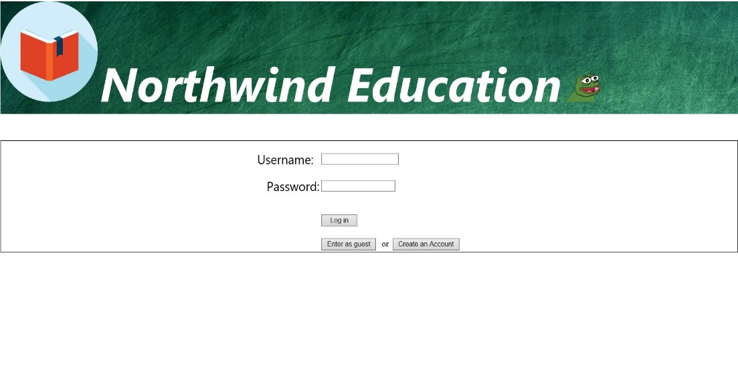

**Create Account**



**Home(Guest)**

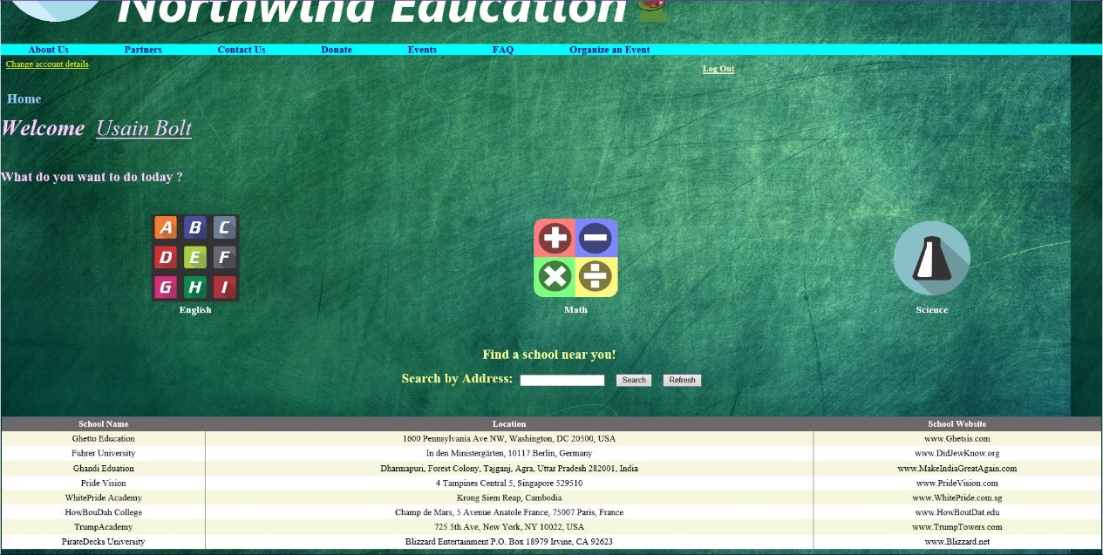

**Home(Member)**

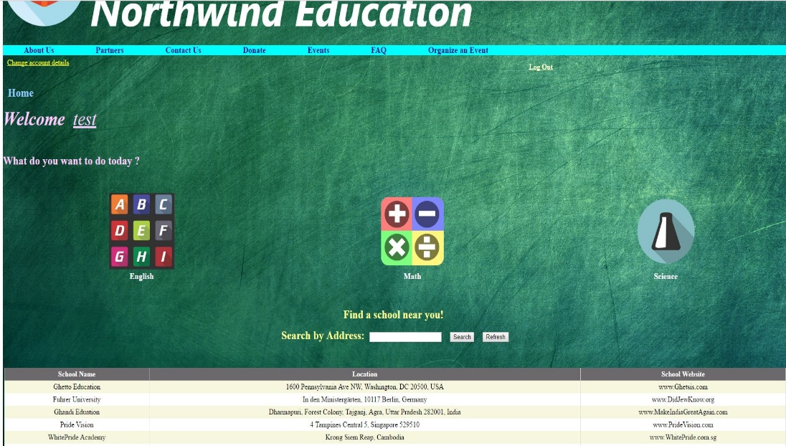

**Home(Admin)**

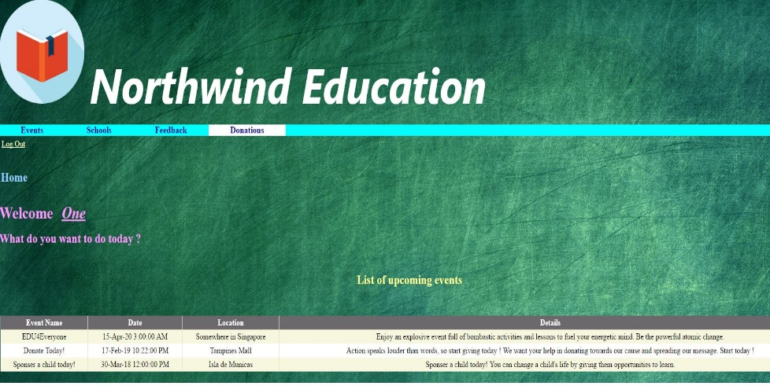

**About Us**



**Partners**



**Contact Us**

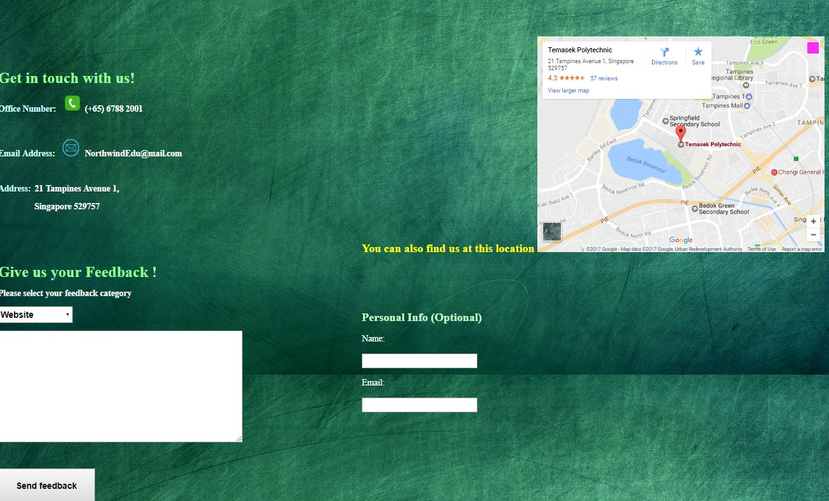

**English Quiz**

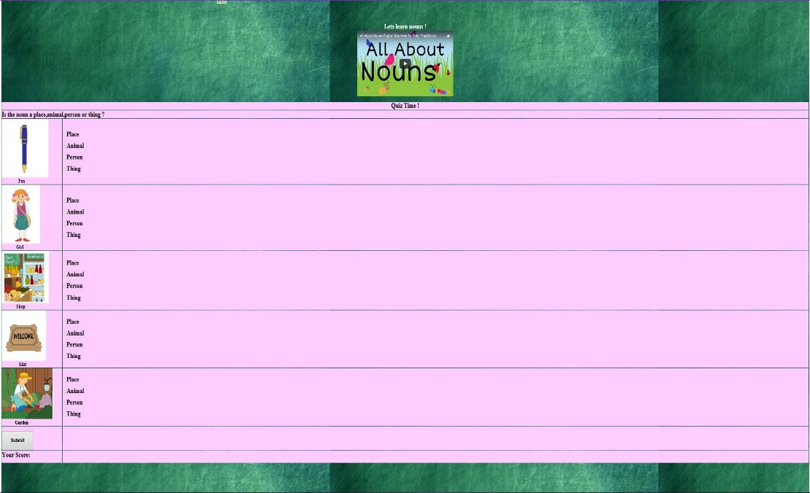

**Math Quiz**

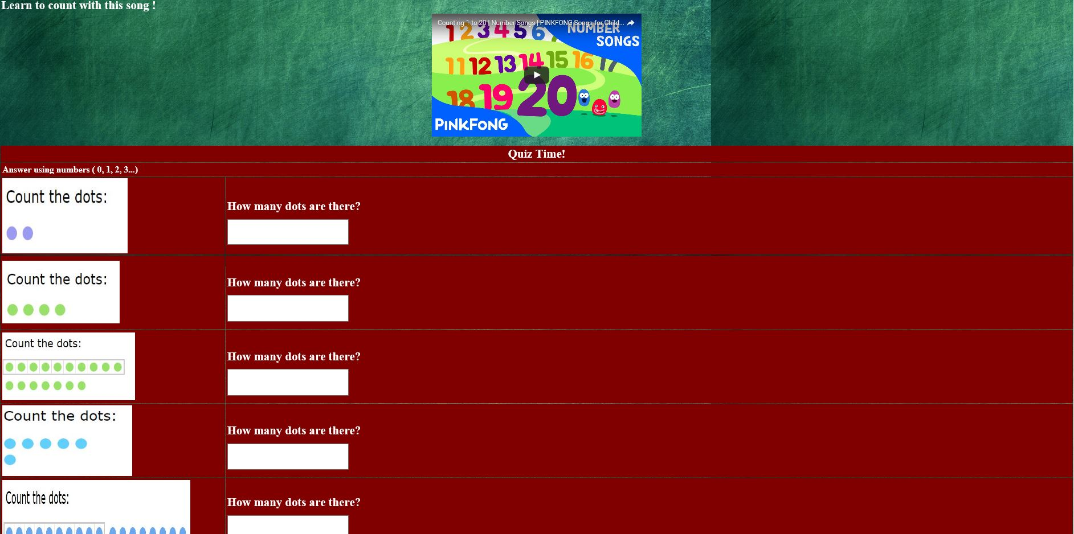

**Science Quiz**

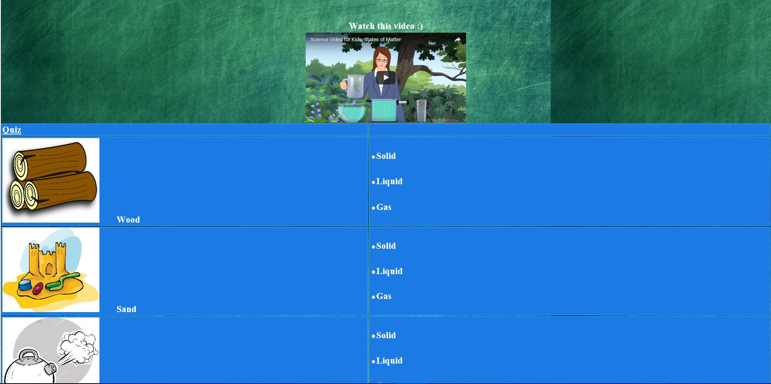

**Donate**

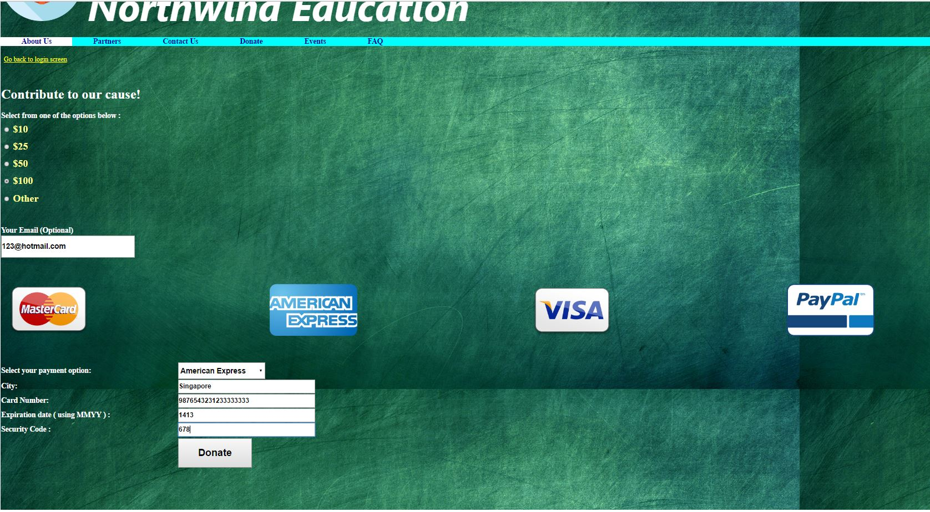

**Organize Events**

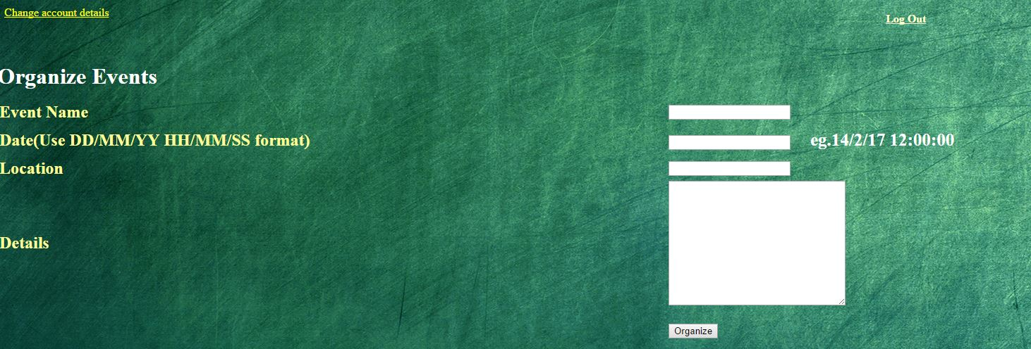

**Update Account info**

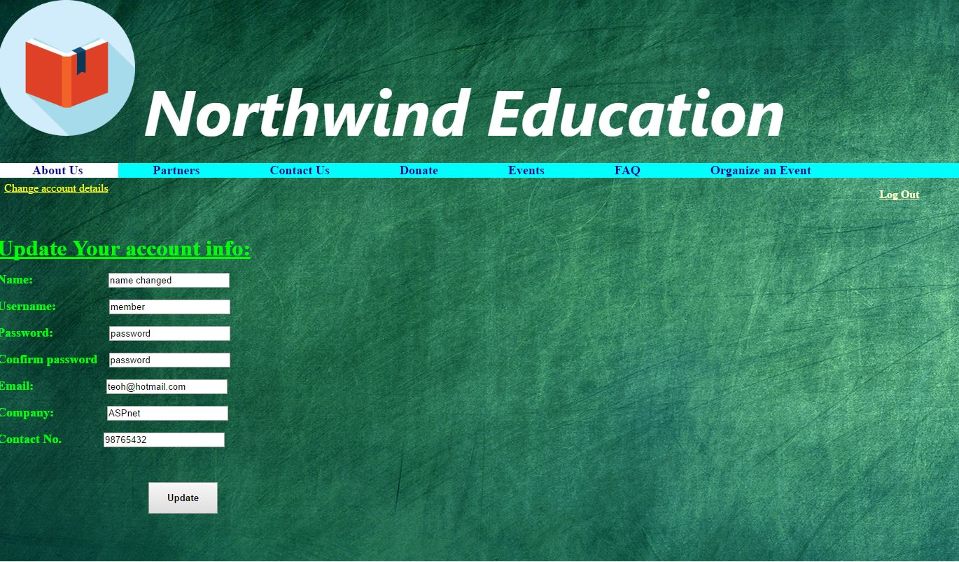

**Add Course**

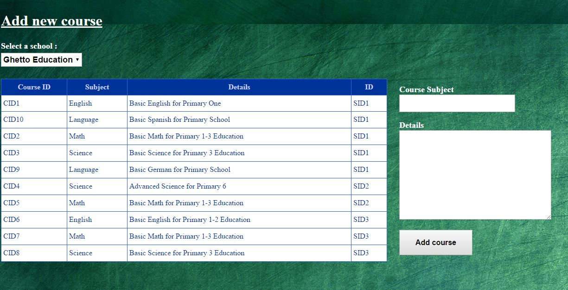

**Add School**

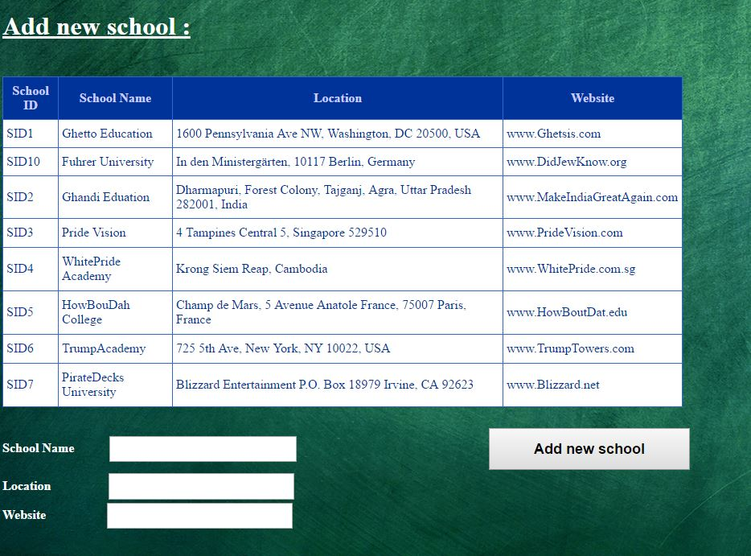

**Insert/Delete/Update Events**

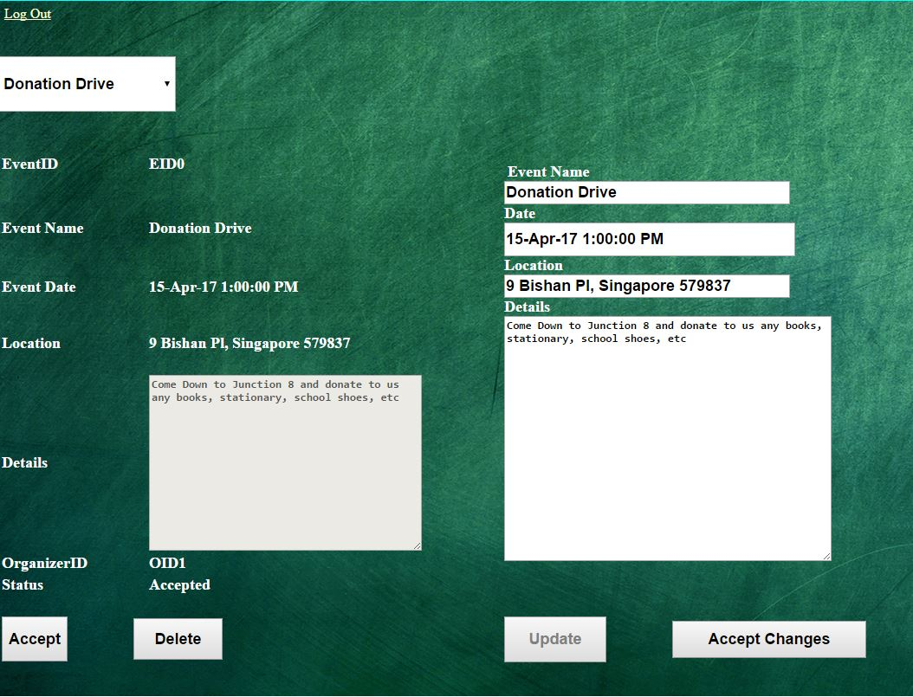

**Feedbacks**

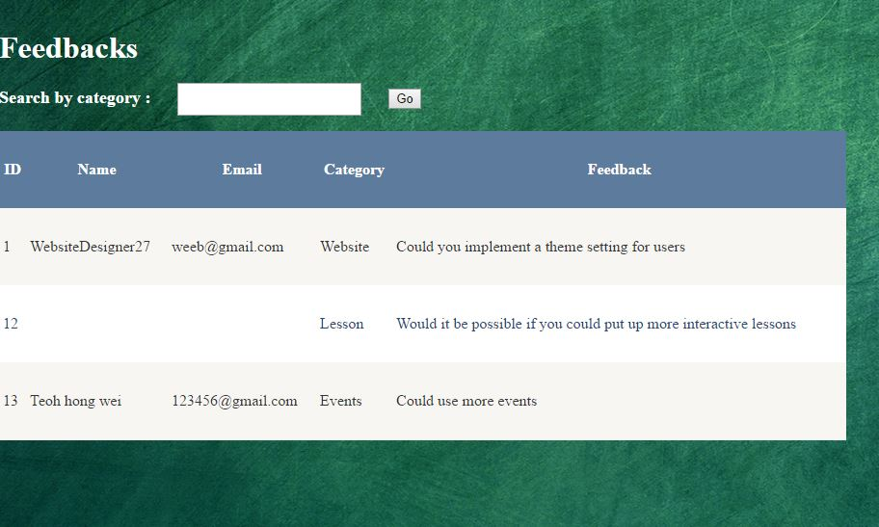

**View Donations**

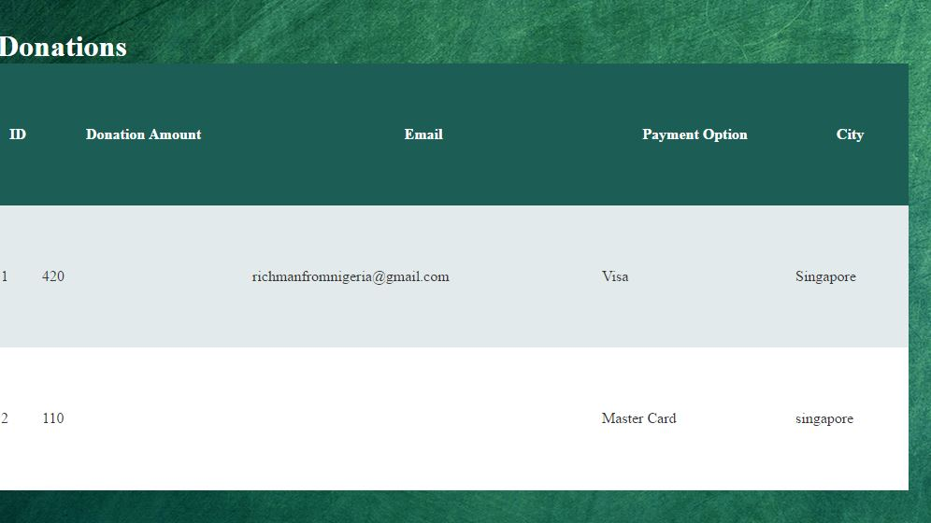

**Delete Course/School**

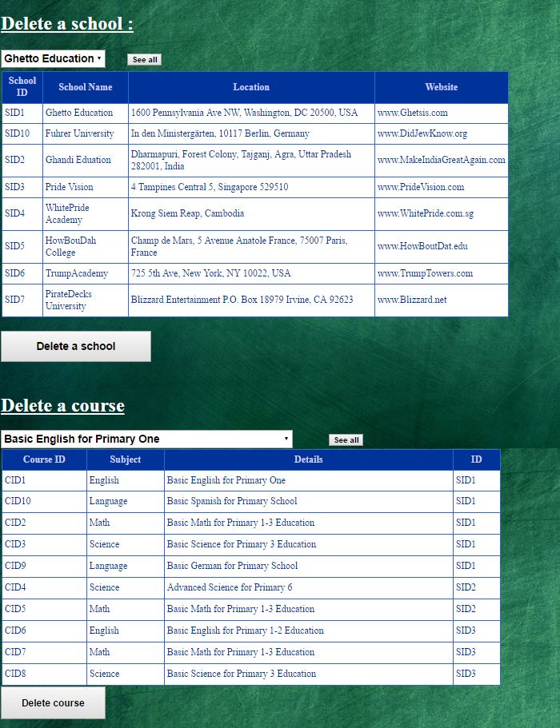

**Update School**

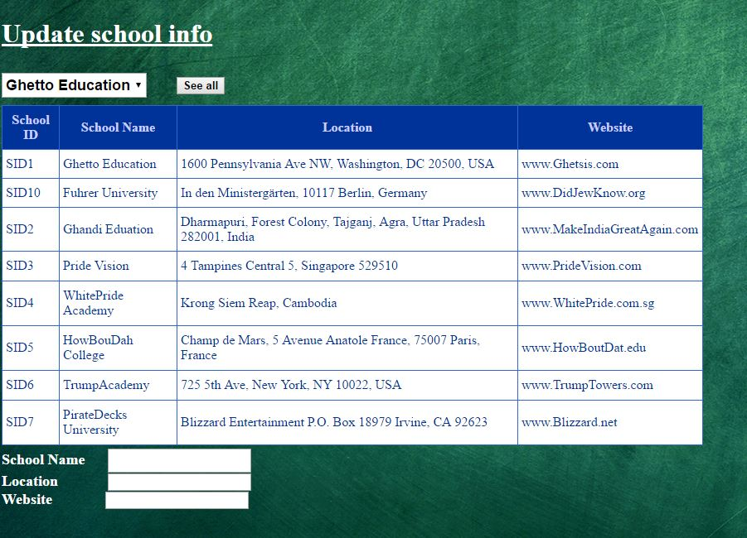

**Update Course**

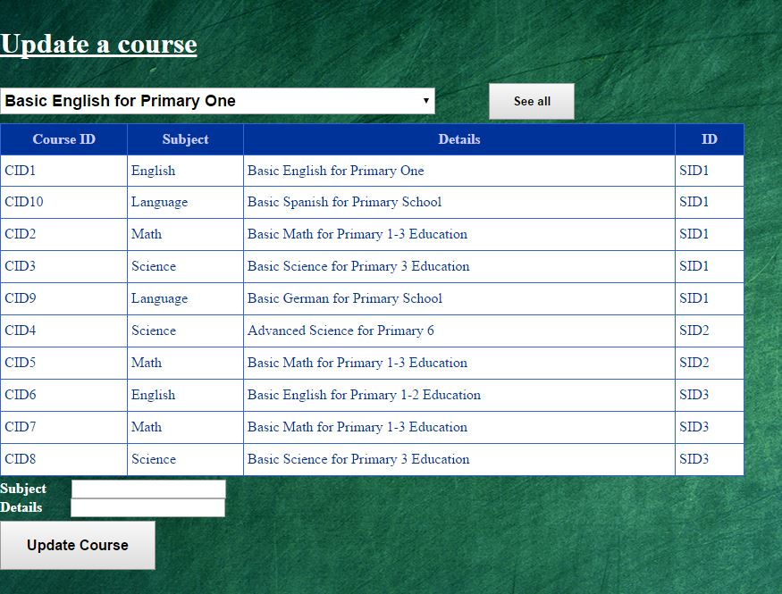

**FAQ**

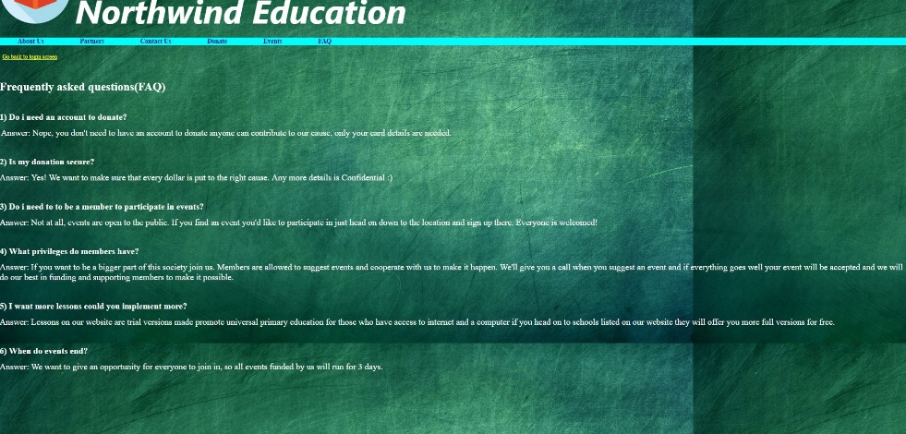

**Events**

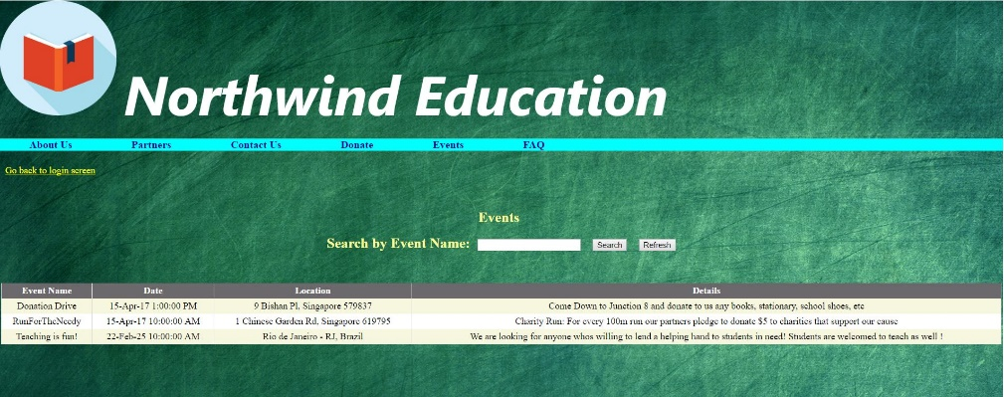

**Update Info (If organize event without contact no/company)**

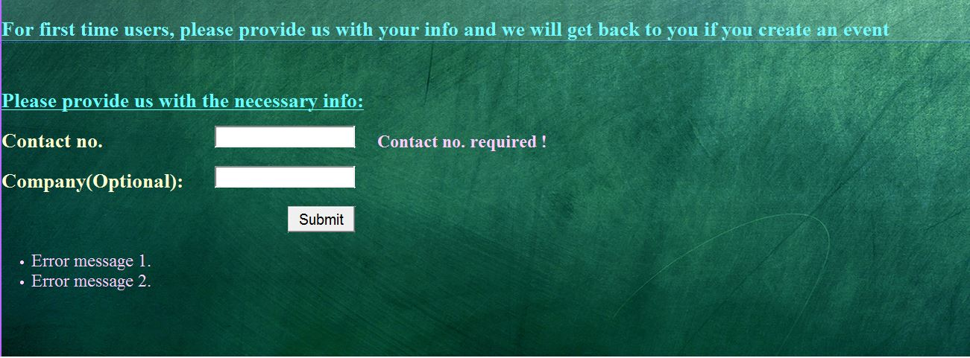

**Thank You**

